A Priori Energy Prediction for Neural Network Training: A Systematic Review of Methods, Measurement Fidelity, and Generalizability
Vanessa Atta-Fynn¹, Kofi Sarpong Adu-Manu¹,*
¹ Department of Computer Science, University of Ghana, Legon, Accra, Ghana
* Corresponding author: Kofi Sarpong Adu-Manu (ksadu-manu@ug.edu.gh)

Abstract
Training energy is cheapest to reduce before a run starts, yet most tools measure it only during training. This review synthesizes methods that predict neural-network training energy, power or carbon before execution and asks how far their accuracy transfers beyond the setting in which they were built. Following PRISMA 2020, six databases were searched between 29 September and 3 October 2026 (2,455 records), complemented by citation searching, a pilot search and one study known to the authors; the protocol was not registered. Sixteen studies were included: eight learned regressors or surrogates, five analytical models, one node-load regression and two simulation or formula-only models. Together they cover CNNs, MLPs, recurrent networks and Transformers. Median quality was 2.75 of 4, and eight studies evaluated on data not used for fitting. Labels came mainly from software estimators or GPU power interfaces. Two studies used node-level measurement, and none validated its instrument against a reference meter. Seven studies were evaluated only in the setting used for fitting, and three refitted per device. The single cross-family test reported errors rising up to sixfold, no study predicted on unseen hardware without target data, and hardware was predominantly NVIDIA. Within a fixed setting, a priori prediction consistently reports low error, but cross-architecture and cross-hardware transfer remain largely untested, and reported accuracies are not comparable because targets, scopes and labels differ. Common reporting of target and transfer setting, externally validated labels, out-of-domain evaluation and harmonized datasets are research priorities, and a 12-item reporting checklist is proposed.
Keywords: Green AI; energy prediction; neural network training; carbon footprint; measurement fidelity; generalizability; systematic review

Highlights
- Sixteen a priori predictors of neural-network training energy are reviewed.
- Coverage includes Transformers and RNNs; one study tests cross-family transfer.
- No predictor is shown to transfer to unseen hardware without target data.
- Most measured labels use software tools or GPU interfaces; none is meter-checked.
- A harmonization protocol is proposed for combining measured energy datasets.

1. Introduction
The energy demand of neural-network training has grown with model scale. Strubell et al. [1] estimated that training and tuning a single large NLP model can emit carbon-dioxide equivalent (CO₂e) comparable to the lifetime emissions of several cars, and Patterson et al. [2] reported approximately 1,287 MWh and 552 tCO₂e for GPT-3, while showing that the joint choice of model, processor, data-center efficiency and energy mix changes training emissions by up to three orders of magnitude. Schwartz et al. [3] accordingly argued that efficiency should be reported alongside accuracy. These choices are least costly to revise before training begins, which is precisely when an energy estimate is most useful.
Most practical tools, however, operate once training is under way. Carbontracker samples GPU, CPU and DRAM power through NVML and RAPL and extrapolates total consumption from the first epoch [4], and experiment-impact-tracker [5] and CodeCarbon [6] likewise measure a running job. Such tools support accounting but cannot inform the architecture, hardware or configuration decision itself; García-Martín et al. [7] observed that few approaches estimated training energy before execution. The evidence base has since expanded. BUTTER-E provides node-level power measurements for a large set of multilayer-perceptron (MLP) training runs [8], and EC-NAS attaches training energy to the NAS-Bench-101 convolutional search space [9] by combining Carbontracker measurements of 4,310 sampled architectures with linear scaling from short runs and an MLP surrogate for the remainder [10]. Predictors now range from layer-wise regression to power laws that cover Transformer, LSTM and GRU training on two GPUs [11].
Existing reviews address adjacent questions (Fig. 1). García-Martín et al. [7] reviewed approaches for estimating the energy consumption of machine-learning algorithms, Bouza et al. [12] compared software tools that track energy during training, Verdecchia et al. [13] mapped 98 Green AI studies, most of which monitor footprints, tune hyperparameters or benchmark models, and Rodriguez et al. [14] systematically reviewed tools and methods for evaluating machine-learning energy at training and inference and compared a selection experimentally. None takes prediction timing as its organizing axis, and none examines how far a priori training-energy predictors transfer across architecture families, across hardware, and against what kind of ground truth. Within the literature located for this review (searches run 29 September – 3 October 2026), no systematic review addresses these questions.
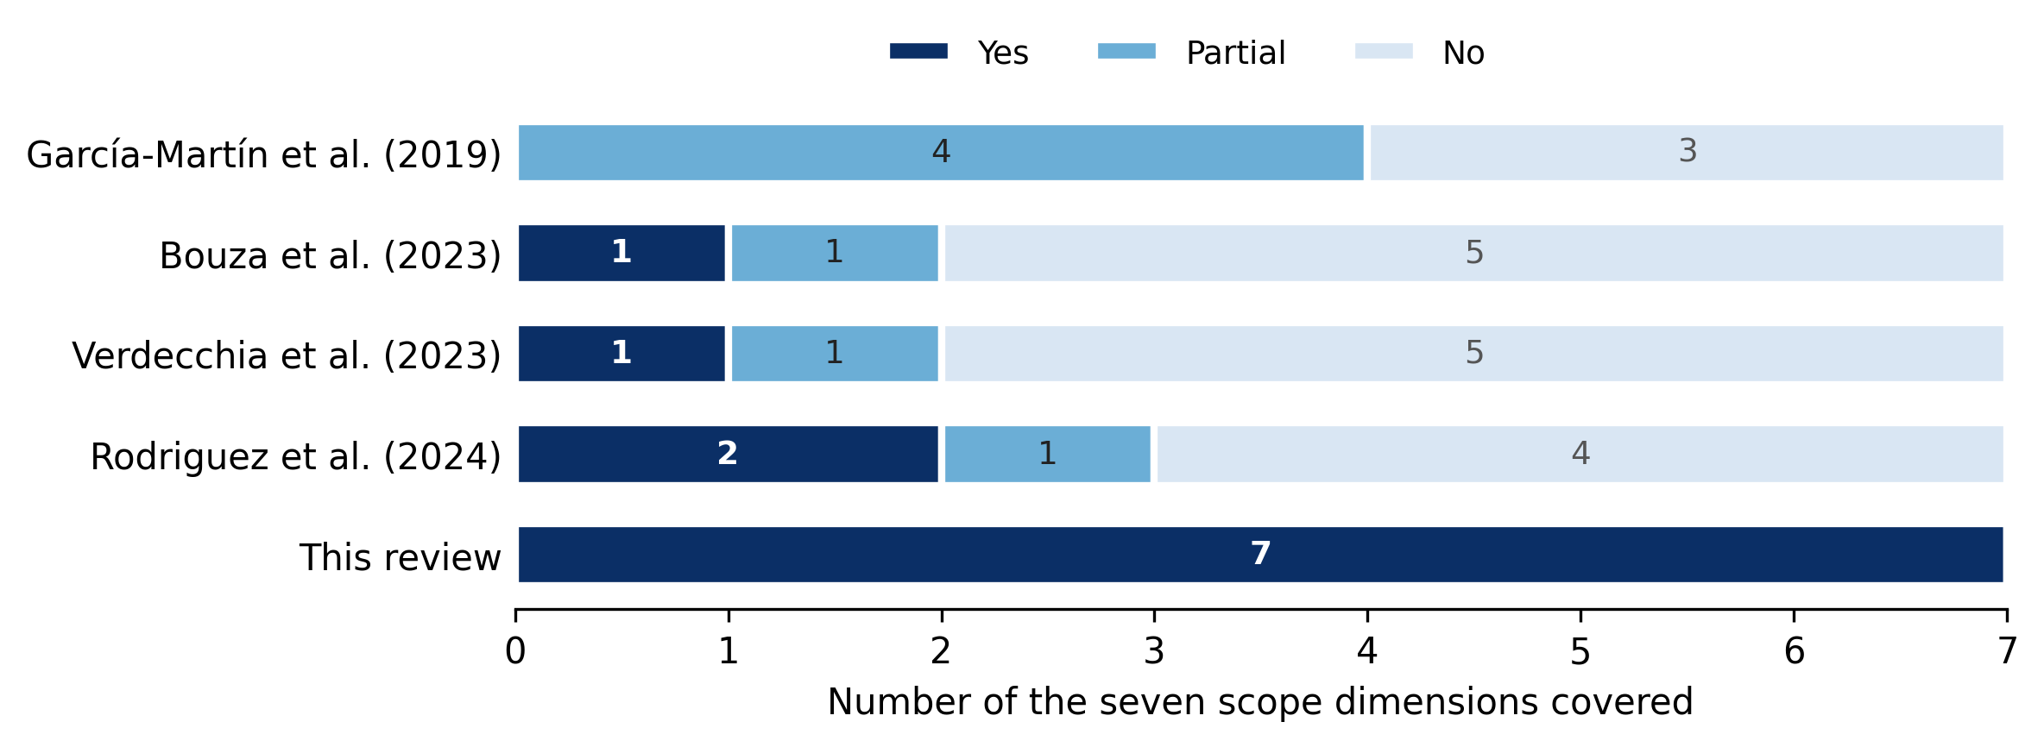
Fig. 1. Number of seven scope dimensions covered by existing reviews and by this review. The dimensions are: systematic method; prediction before training; training-phase focus; cross-architecture transfer; cross-hardware transfer; appraisal of how energy values were measured; and reporting guidance for predictors. Partial: covered as part of a broader scope or as practical advice rather than a reporting standard. Scope is taken from each review’s stated aims and methods.
The overarching question is therefore whether a priori training-energy predictors can be used outside the setting in which they were built, decomposed into three research questions:
RQ1 (methods and inputs). Which methods have been proposed to predict neural-network training energy before execution, and which input features do they use?
RQ2 (label and measurement fidelity). How were the energy values used to fit and validate these predictors obtained, and how reliable is that ground truth?
RQ3 (transferability). How have these predictors been evaluated across architectures, datasets and hardware, whether in the same setting used for fitting, after recalibration or zero-shot, and what limits their transfer?
This review makes four contributions: (i) a reproducible, PRISMA 2020-compliant corpus of a priori training-energy predictors drawn from six databases, citation searching, a pilot search and one study known to the authors, restricted to methods that estimate training energy, power or carbon before the target run; (ii) a generalizability matrix recording, for each predictor, the architecture family, hardware, target quantity, ground-truth instrument and transfer setting; (iii) an appraisal of how training labels were measured and what this implies for interpreting reported accuracy; and (iv) a reporting checklist for future a priori predictor studies, derived from the gaps identified. Section 2 describes the protocol, Section 3 reports the results, Section 4 discusses cross-study implications, Section 5 addresses threats to validity, and Section 6 concludes.

2. Methods
The review follows the guidelines of Kitchenham and Charters [15] and is reported according to the PRISMA 2020 statement [16]. The protocol was not registered, and no separate protocol document was published. Search logs, screening decisions with reasons, full-text eligibility decisions, extracted data and quality scores are provided in Supplementary Material S1.

2.1 Target quantities
The included studies predict different quantities that are not interchangeable. Fig. 2 places them on a causal chain from architecture and training configuration, through runtime and power draw (W), to operational energy (J, kWh) and, via grid carbon intensity and data-center power usage effectiveness (PUE), to carbon emissions (CO₂e). Embodied emissions from hardware manufacture form a separate lifecycle component that does not follow from the training run. The link predicted by each study is recorded during extraction (Section 2.6).
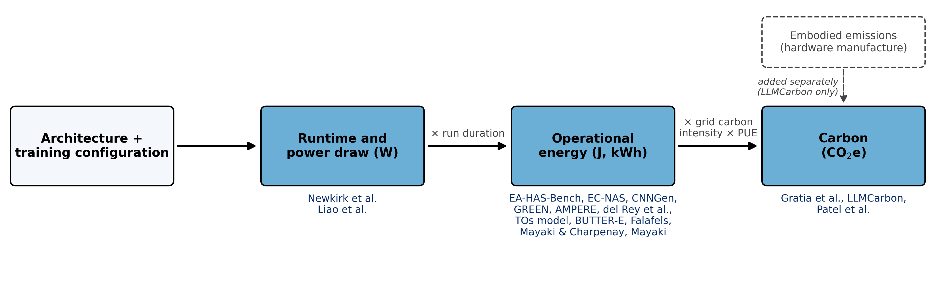
Fig. 2. Target quantities on the causal chain from training configuration to carbon emissions, with the included studies placed at the link they predict. Newkirk et al. predict node power and convert it to energy using measured duration; Liao et al. predict power-curve components, including peak power and valley-phase energy.

2.2 Eligibility criteria
A method is a priori if it produces its estimate using only inputs available before the target training run starts, namely the architecture, the training configuration (for example batch size, number of epochs or expected duration) and a description of the hardware. One-off calibration on other workloads or on the target device is permitted, for example fitting a model to other measured runs or profiling small reference networks once per device. Running any part of the target training job, including the first epoch, a few iterations or profiling the target under some settings, is not a priori.
A study was included only if all four criteria held: I1, the object is the training of a neural network of any architecture, including fine-tuning and federated or distributed training; I2, the study proposes or evaluates a method that outputs an estimate of training energy, power or carbon, whether a learned model, analytical model, surrogate, simulator, calculator, power law or lookup table, whereas a ranking score without an energy, power or carbon value does not qualify; I3, the estimate is a priori as defined above; and I4, the study is in English, published in 2016–2026, and is a full research paper (journal, conference or workshop paper, or preprint) with a method and an evaluation, where an evaluation is any reported experiment or case study that applies the method, not necessarily a comparison with measured energy. Excluded records received the first applicable code in Table 1. Studies excluded under E8 are not counted in the synthesis or the quality appraisal and are cited, where relevant, as background only.
Table 1. Exclusion codes.
Code | Reason
E1 | Neural networks are not the predicted object (e.g., building, grid or vehicle energy forecasting; general GPU, HPC or server power models; accelerator design; scheduling)
E2 | Does not address energy, power or carbon
E3 | No prediction or estimation method
E4 | Not a full research paper
E5 | Not in English
E6 | Earlier or shorter version of an included paper
E7 | Full text not retrievable
E8 | Not an a priori training-energy predictor (inference only; measurement or extrapolation during training; post-hoc accounting; surveys or frameworks without such a predictor)

2.3 Information sources and search strategy
Six databases were searched (Table 2). Five were searched on 29 September 2026. SpringerLink was first searched on the same date with an English-language filter and re-run on 3 October 2026 without it, so that language was handled identically across sources; the re-run added one record. Searches used title, abstract and keyword fields in Scopus, Web of Science and ScienceDirect, the abstract field in IEEE Xplore and ACM Digital Library, and title and keyword fields in SpringerLink (Table 2), restricted to 2016–2026. Each query combined three concept blocks: an energy term (energy consumption, power consumption, energy cost, energy usage), a neural-network or compute term (training, neural network*, deep learning, DNN*, CNN*, GPU*) and a prediction term (predict*, estimat*, forecast*). In Scopus and Web of Science, the first two blocks were linked by a proximity operator (W/4 and NEAR/4). A NOT block removed off-domain energy forecasting (building*, household*, smart grid, power grid, load forecasting, electric vehicle*, photovoltaic, solar, wind power). Three platform adaptations were required. ACM has no proximity operator, so the blocks were joined with AND and the search was run on the abstract field. ScienceDirect permits at most eight Boolean operators and no wildcards, so a reduced query with a Computer Science subject filter replaced the NOT block. SpringerLink lacks an abstract-field search, so energy and prediction terms were searched in titles and neural-network terms in keywords. Full query strings are given in Appendix A.
Table 2. Database searches (2016–2026).
Database | Fields | Date | Records
Scopus | TITLE-ABS-KEY; Computer Science | 29 Sep 2026 | 628
SpringerLink | Title + keywords; Computer Science; articles and conference papers | 3 Oct 2026 | 628
ScienceDirect | Title, abstract, keywords; Computer Science | 29 Sep 2026 | 440
ACM Digital Library | Abstract | 29 Sep 2026 | 349
IEEE Xplore | Abstract | 29 Sep 2026 | 282
Web of Science | Topic (TS) | 29 Sep 2026 | 128
Total |  |  | 2,455
Before screening, recall was checked against four studies known in advance to meet the eligibility criteria: EC-NAS [10], Gratia et al. [17], Mayaki and Charpenay [11] and the transistor-operations (TOs) model [18]. The first three were retrieved; the TOs model was not, because its published abstract contains none of the prediction terms. This result motivated the supplementary sources described in Section 2.5.

2.4 Deduplication
All 2,455 records were merged and deduplicated before screening in three passes: exact DOI match; exact match on the normalized title (lower case, punctuation removed); and fuzzy title match (token-sort similarity ≥ 94, publication year within ±1), excluding correction and retraction notices. The passes removed 300 duplicates, leaving 2,155 unique records.

2.5 Study selection
Screening was performed by a single reviewer in three stages. At the title stage, a record was retained unless the title clearly placed it out of scope; a record was in scope if it could concern estimating, predicting, modeling or measuring the energy, power or carbon of neural-network computation. This stage was deliberately wider than the eligibility criteria so that no candidate predictor was lost. In total, 184 records proceeded to the abstract stage. At the abstract stage, criteria I1–I3 were applied, and a record was retained if it indicated a method that estimates the training energy, power or carbon of a neural network before or without running that training, or if the abstract left the training-versus-inference or a priori status unclear. Of these, 162 records were excluded (98 E8, 59 E1, 4 E3, 1 E4) and 22 proceeded to full text. At the full-text stage, criteria I1–I4 were applied. Four of the 22 reports could not be assessed: three were behind paywalls not covered by institutional access (E7), and one, a distributed-training energy model (MC2), is available only in Chinese (E5). Of the 18 assessed, 10 were excluded under E8, six of them because they require part of the target job to be run first or output only a ranking index. Eight studies were included from the database search.
One round of backward and forward snowballing [19] was run on these eight studies. Backward candidates were taken from their reference lists (249 references), and forward candidates were papers citing them, retrieved from Semantic Scholar on 2–3 October 2026 (43 papers). The 292 records were screened in the same three stages with the same criteria. After removal of 40 duplicates within the set and 16 records already in the database results, 236 records were title-screened and 163 excluded, including 26 outside 2016–2026; 73 abstracts were screened and 61 excluded; and 12 full texts were assessed, of which six were excluded (five E8, one E4) and six included.
A pilot search carried out in March–April 2026 had identified 26 studies on the topic. It combined title-only searches of IEEE Xplore, ACM Digital Library, ScienceDirect and SpringerLink, using combinations of neural-network, energy-consumption, training, prediction and neural-architecture-search terms, with Google Scholar searches and backward reference checking. All 26 studies were re-assessed against I1–I4. Three met the criteria; two had already been included through the database search, so one new study [18] was added. The remaining 23 were excluded under E8 or, in one case, E1, and five of them had already been excluded during database screening. Finally, one study known to the authors from related work, Liao et al. [20], had not been retrieved by any search, most likely because it appeared in a journal outside the Computer Science subject filters; it was assessed against I1–I4 in full text and included. In total, 16 studies were included: eight from databases, six from citation searching, one from the pilot search and one known to the authors (Fig. 3).
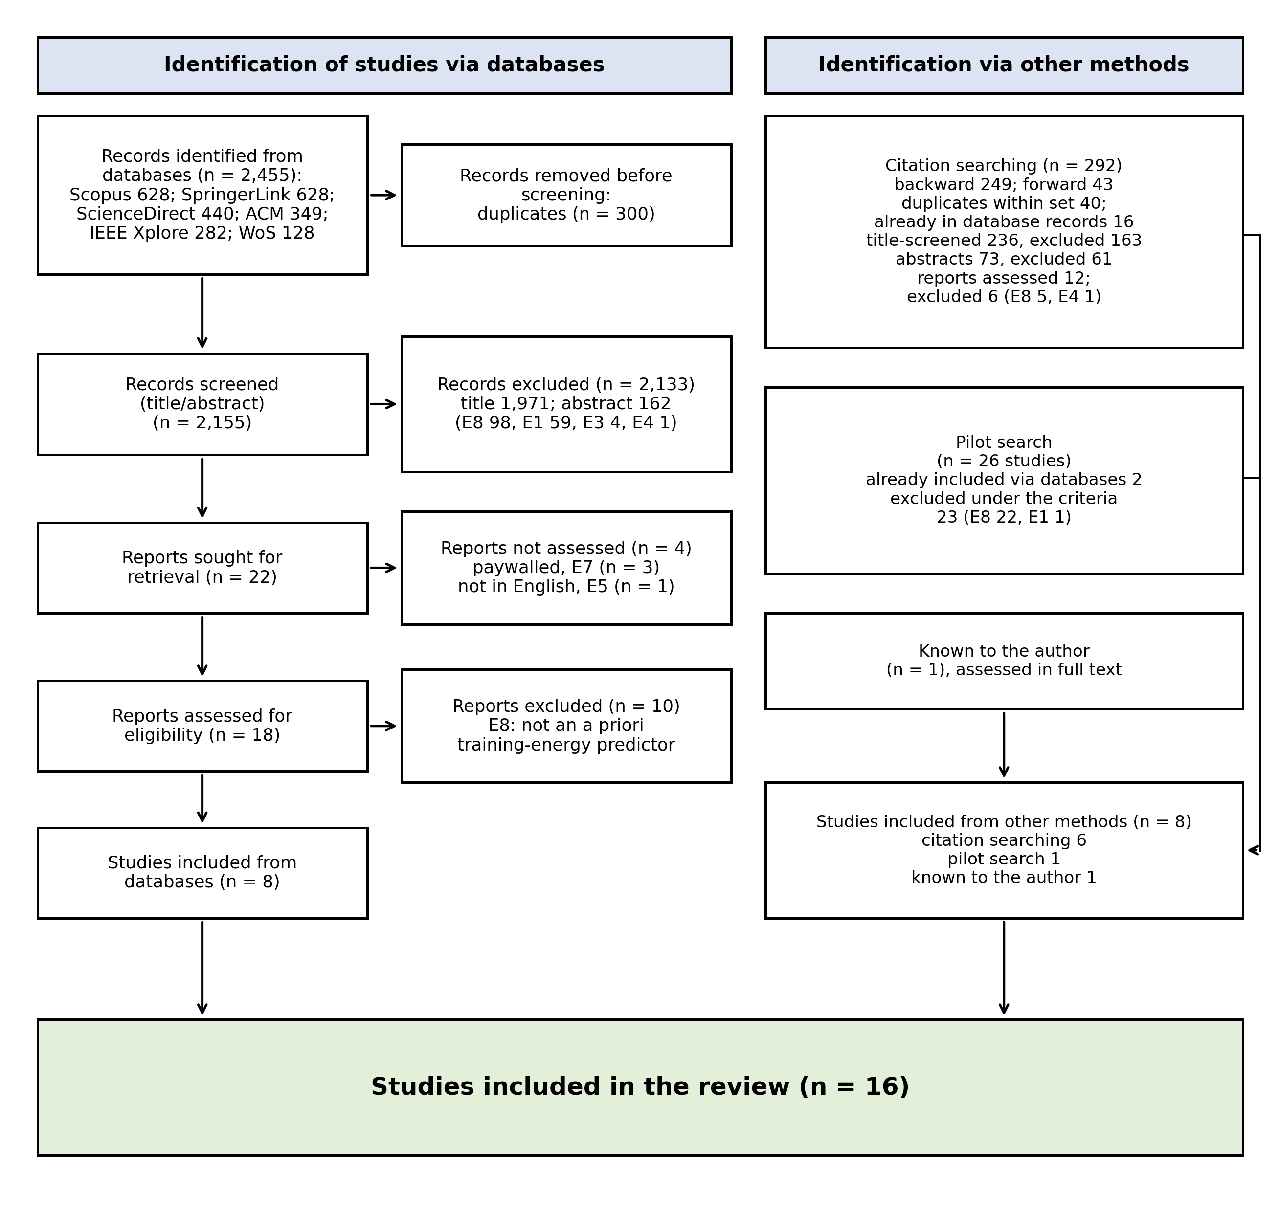
Fig. 3. PRISMA 2020 flow diagram.

2.6 Data extraction
A structured form was applied to every included study (Table 3). Every value had to be traceable to the paper, “not reported” was recorded where the paper was silent, and all values were verified against the source.
Table 3. Data items.
Item | Content | RQ
Quantity predicted | Energy, power or carbon; unit; scope (run, epoch, round, phase) | –
Method | Learned model, analytical model, surrogate, simulator, calculator or power law | RQ1
Input features | Architecture descriptors, training configuration, hardware descriptors | RQ1
Architectures and tasks | Network families and datasets | RQ1, RQ3
Hardware | Devices used to collect labels or validate | RQ2, RQ3
Ground truth | Instrument, components covered, sampling rate | RQ2
Measurement validation | Instrument checked against a reference meter | RQ2
Dataset size | Configurations or runs used to fit and evaluate | RQ3
Evaluation protocol | Split type; transfer setting (same setting, recalibrated, zero-shot) | RQ3
Cross-hardware | Whether and how results are reported on more than one device | RQ3
Accuracy | Headline error metrics as reported | RQ1, RQ3
Availability | Code or data released | –

2.7 Quality appraisal
All included studies are empirical method studies, so a single instrument applies. Each study was scored Yes (1), Partial (0.5) or No (0) on four domains, for a maximum of 4. D1 (data described) is Yes if configurations, datasets and hardware are all described well enough to reproduce the study, Partial if one is missing or vague, and No otherwise. D2 (ground truth described) is Yes if the instrument and the components covered or sampling are stated, Partial if a tool is named without that detail or labels are taken from another paper with little description, and No if no measurement is described. D3 (appropriate validation) is Yes if accuracy is evaluated on unseen configurations, workloads or datasets, Partial if the held-out set is weak (a random split over repeated runs of the same configurations, an undescribed split, or comparison with published values whose inputs partly derive from the target runs), and No for in-sample fit only or no comparison with measurement. D4 (quantitative results) is Yes for a defined error or fit metric (e.g., MAPE, RMSE, MAE in physical units, R²), Partial if only rank correlation, an undefined or unitless metric, or internally inconsistent values are reported, and No if no error metric is given. Two reporting items, R1 (aim clearly stated) and R2 (limitations discussed), were recorded but not scored. Generalizability is assessed through the RQ3 extraction fields rather than as a quality item. Each study was scored in two separate passes from the full text and differences were reconciled against these rules. Scores qualify the strength of evidence; no study was excluded on quality grounds, and preprints were appraised with the same instrument as peer-reviewed papers.

2.8 Synthesis
Because the studies differ in target quantity, measurement instrument, hardware and evaluation protocol, no meta-analysis was attempted. The synthesis is narrative and organized by research question, supported by a capability matrix and a generalizability matrix of architecture family × hardware and vendor × target quantity × ground-truth instrument × transfer setting. Reporting bias was not assessed formally and is discussed qualitatively (Section 5); no formal certainty-of-evidence framework was applied, and the quality scores of Section 2.7 are used to qualify the strength of each finding.

3. Results

3.1 Study selection
Fig. 3 summarizes the selection. Of the 31 full texts assessed (18 from the databases, 12 from citation searching and one known to the authors), 16 were excluded, as were 23 of the 26 studies from the pilot search. Six excluded studies came closest to the eligibility criteria because they estimate training energy, power or carbon but fail criterion I3 or I2 (Table 4). Supplementary Material S1 lists every excluded full-text report with its reason.
Table 4. Studies that appeared to meet the eligibility criteria but were excluded at full text.
Study | What it estimates | Reason for exclusion
Han and Chen [21] | Training energy and time from model, batch size and GPU count | Unseen configurations require a short run of the target job (I3)
He et al. [22] | GPU power and runtime of untried training settings | Requires one epoch of the target job at default settings (I3)
Rościszewski [23] | Power and time of parallel training on 1–8 GPUs | Simulator tuned on single-GPU runs of the target job (I3)
Prashanthi et al. [24] | Per-epoch training energy on Jetson power modes | Requires four profiled power modes of the target job (I3)
Symeonides and Trihinas [25] | Energy and carbon of federated training scenarios | Built from measured power traces of the training nodes (I3)
Sangarya et al. [26] | Relative cost of retraining before it starts | Ranking score without an energy, power or carbon value (I2)

3.2 Study characteristics
The 16 included studies (Table 5) are recent: 14 were published in 2024–2026, with the remaining two in 2022 [18] and 2023 [27] (Fig. 4). Eleven predict operational energy, three predict carbon [17,28,29], and two predict power: Newkirk et al. [30] predict node power and convert it to energy using measured duration, whereas Liao et al. [20] predict power-curve components comprising peak power, peak and valley durations, and valley-phase energy. Gratia et al. [31] report a carbon target in the text but label their results table “energy”. The scope of prediction also differs: nine studies predict a whole training run, five predict energy at epoch level [11,27,32–34], the last as cumulative energy up to each epoch, one predicts a federated round [29], and one predicts power-curve phases [20].
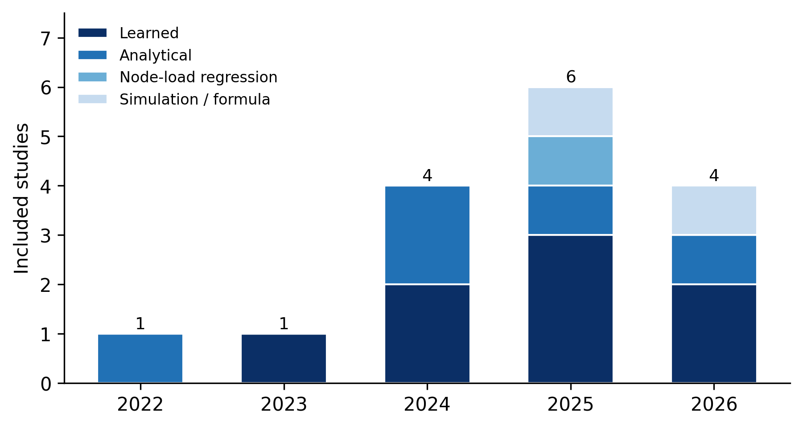
Fig. 4. Included studies by publication year and method family.
Table 5. Characteristics of the included studies.
Study | Predicts | Method | Networks | Hardware | Ground truth
EA-HAS-Bench [27] | Energy per epoch (kWh) | LightGBM surrogate | RegNet CNN space | V100 | pynvml GPU power (0.1 s)
EC-NAS [10] | Energy (kWh) per run | MLP surrogate | NAS-Bench-101 CNN cells | Quadro RTX 6000 | Carbontracker (GPU, CPU, DRAM; 10 s)
CNNGen [31] | Carbon/energy per run | Decision tree | 1,300 generated CNNs | Not reported | CodeCarbon
Gratia et al. [17] | Carbon (g CO₂e) per run | Random forest in a genetic NAS | 40,000 generated CNNs | Not reported | Own runs; instrument not restated
GREEN [34] | Cumulative energy per epoch (normalized) | Transformer predictor | CNN, ViT, BERT-family, LLM, recommender | A100, RTX 4090, L40S | CodeCarbon (CPU, GPU)
AMPERE [35] | Energy (J), on-device training | Per-layer Gaussian processes | CNN, LSTM, Transformer, ResNet | Smartphones, Jetson Xavier/TX2, server | Not described in the published version
del Rey et al. [33] | Power × duration, or energy per epoch | Kernel ridge regression | Six CNNs (transfer learning) | GTX 750 Ti, RTX 3070, RTX 3090 | nvidia-smi (1 s) + RAM coefficient
Liao et al. [20] | Power-curve components | Symbolic regression | ResNet-18/34/50/101, VGG16, MobileNet, ViT, BERT | A800 (1 and 4 GPUs); RTX 2080 Ti (supplementary) | nvidia-smi GPU power (0.1 s)
TOs model [18] | Energy (J) per run | Transistor-operation count + polynomial regression | MLP, small CNNs | Intel/AMD CPUs, RTX 3080 | On-board sensors, single CPU or GPU package (Power Gadget, GPU-Z)
BUTTER-E [8] | Node energy (J) per run | Cache-aware linear model | MLPs | Xeon CPU nodes; V100 nodes | Node power, HPE iLO (1 min)
LLMCarbon [28] | Carbon (tCO₂e), operational + embodied | Analytical pipeline + hardware-efficiency regression | Dense and MoE LLMs | TPUv3, V100 | Published footprints
Mayaki and Charpenay [11] | Energy per epoch | Per-operation power laws + linear regression | Transformer, LSTM, GRU | A100, RTX 2080 Ti | CodeCarbon + Nsight (GPU, CPU, RAM)
Mayaki [32] | Energy per epoch (kWh), fine-tuning | Roofline-style log-linear power law | BERT fine-tuning | RTX 2080 Ti | Nsight + CodeCarbon
Newkirk et al. [30] | Node power (kW) → energy | Non-linear regression on FLOPs per node | GPT-3, Llama, ResNet, UNet-3D | 8×H100 nodes (1–64) | Node-level power (≈2 s; 5 min)
Falafels [36] | Energy of a federated run | Discrete-event simulation | MLP (federated) | Simulated devices | None
Patel et al. [29] | Carbon per federated round | FLOP-based formula in NAS | CNN search space (federated) | Simulated devices | None
LLM: large language model; MoE: mixture of experts; NAS: neural architecture search; HPE iLO: Hewlett Packard Enterprise Integrated Lights-Out management chip.

3.3 Quality appraisal
The median score was 2.75 of 4 (range 0–4; Table 6), and no single domain was markedly weaker than the others, with six to eight studies scoring Yes in each. Eight studies tested their predictor on configurations, workloads or datasets not used for fitting; five relied on weaker held-out sets, such as random splits over repeated runs, undescribed splits or published values with partly target-derived inputs; and three reported in-sample fit only or no comparison with measurement. Eight studies stated both the instrument and the components it covered, whereas three described no measurement. Only six reported a clearly defined error metric; the others reported rank correlation, unitless or undefined metrics, or values that disagree within the paper. The two simulation and formula studies [29,36] never compare their estimates with measured energy and score 0 and 0.5, respectively.
Table 6. Quality appraisal (Y = 1, Partial = 0.5, N = 0).
Study | D1 Data | D2 Ground truth | D3 Validation | D4 Metrics | Score
EA-HAS-Bench [27] | Y | Y | Y | Y | 4.0
Liao et al. [20] | Y | Y | Y | Partial | 3.5
GREEN [34] | Y | Y | Y | Partial | 3.5
del Rey et al. [33] | Y | Y | Partial | Y | 3.5
TOs model [18] | Y | Y | Partial | Y | 3.5
Newkirk et al. [30] | Y | Partial | Y | Y | 3.5
EC-NAS [10] | Partial | Y | Y | Partial | 3.0
LLMCarbon [28] | Y | Partial | Partial | Y | 3.0
CNNGen [31] | Partial | Partial | Y | Partial | 2.5
Gratia et al. [17] | Partial | Partial | Y | Partial | 2.5
Mayaki and Charpenay [11] | Partial | Y | Partial | Partial | 2.5
BUTTER-E [8] | Y | Y | N | Partial | 2.5
Mayaki [32] | Partial | Partial | Partial | Partial | 2.0
AMPERE [35] | N | N | Y | Y | 2.0
Patel et al. [29] | Partial | N | N | N | 0.5
Falafels [36] | N | N | N | N | 0.0

3.4 RQ1: Methods and input features
The predictors fall into four method families (Fig. 5). Learned regressors and surrogates (eight studies) fit a statistical model to measured runs and predict new configurations: Bakhtiarifard et al. [10] train an MLP surrogate, Dou et al. [27] LightGBM, Gratia et al. a decision tree [31] and a random forest [17], del Rey et al. [33] kernel ridge regression, Zhang et al. [35] per-layer Gaussian processes, Betello et al. [34] a transformer, and Liao et al. [20] genetic-programming symbolic regression. Four of these are built for neural architecture search (EC-NAS, EA-HAS-Bench, CNNGen and Gratia et al.). Analytical or semi-empirical models (five studies) derive energy from counted operations with few fitted coefficients: transistor-operation counts [18], per-operation power laws [11], a roofline-style law over FLOPs and memory traffic [32], a cache-aware linear model [8], and an end-to-end FLOP, hardware-efficiency and carbon pipeline [28]. Newkirk et al. [30] regress node power on effective FLOPs per node, while Falafels [36] and Patel et al. [29] rely on simulation or closed-form formulas without a fitted component.
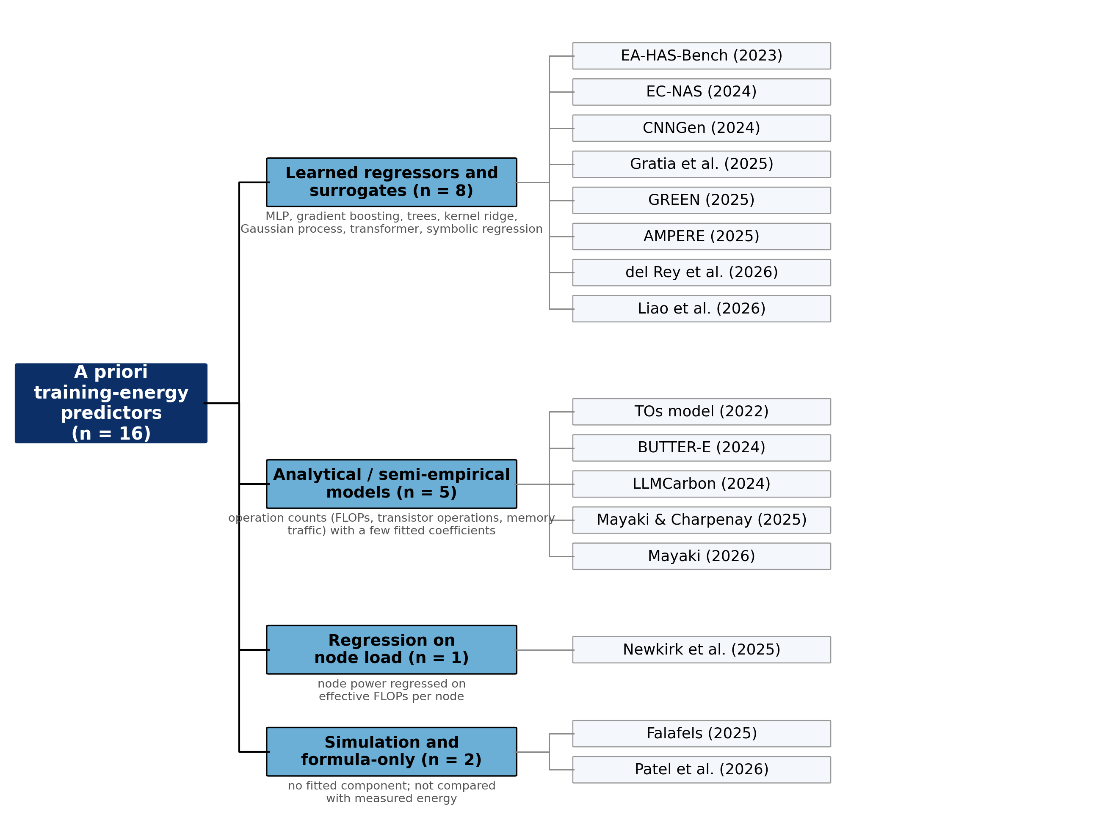
Fig. 5. Taxonomy of the included a priori training-energy predictors by method family.
Thirteen studies describe the network through a count of computational work, such as FLOPs, operation counts or parameters. The remaining three use architecture-specific encodings: a NAS-Bench-101 cell graph [10], RegNet design parameters [27], and per-layer type, channels, kernel, stride and batch size [35]. Fourteen studies also take the training configuration (batch size, epochs, dataset size or tokens) as input, whereas EC-NAS and Gratia et al. [17] fix the schedule. Explicit hardware descriptors are less common: GPU specifications [33], peak throughput [11,28], an infrastructure feature vector [34], per-device efficiency in FLOPs per joule [29], and compute profiles of simulated machines [36]. Two studies model memory traffic [8,32], whereas LLMCarbon treats memory only as a capacity constraint [28]; Tripp et al. [8] show that energy per FLOP changes as the working set moves across cache levels, which operation counts alone cannot capture.

3.5 RQ2: Label and measurement fidelity
Fig. 6 cross-tabulates the instrument behind each study’s energy labels with the system components it covers. Two studies use node-level measurement: power read from the servers’ integrated management chip (HPE iLO) at one-minute resolution [8], and node power at approximately two-second and five-minute intervals [30]. Three read GPU power interfaces [20,27,33], one uses on-board sensor utilities [18], and five rely on software estimators, CodeCarbon or Carbontracker, sometimes alongside profilers [10,11,31,32,34]. The remaining five do not report how their labels were measured: Faiz et al. [28] use footprints published by other studies, Gratia et al. [17] train 40,000 generated architectures without restating the instrument, Zhang et al. [35] do not describe the instrument in the published version, and the two simulation studies measure nothing.
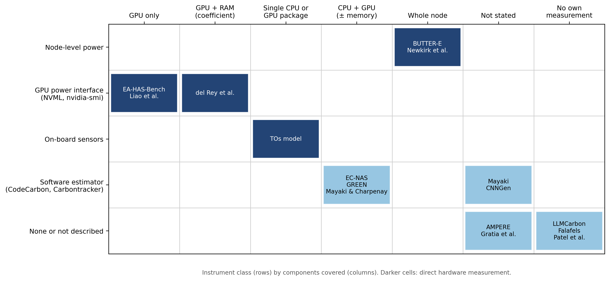
Fig. 6. Instrument class and component coverage of the energy labels used to fit and validate each predictor. Darker cells denote direct hardware measurement.
Component coverage varies as much as the instrument. Labels range from GPU-only power [20,27], through GPU power plus a fixed RAM coefficient without CPU [33], a single processor package measured with the program pinned to one CPU or GPU [18], and CPU and GPU together, with memory in two cases [10,11,34], to the whole node [8,30]. None of the 16 studies checked its instrument against an external reference meter.

3.6 RQ3: Transferability
Fig. 7 summarizes the capabilities that bear on transfer, and Table 7 gives the generalizability matrix underlying it. Evaluation is predominantly same-setting: seven studies are evaluated only on the hardware and model family used for fitting, and three refit the predictor for each new platform [11,18,35]. Newkirk et al. [30] test on workloads held out from fitting but on the same H100 node class, and Faiz et al. [28] compare against models from other studies without refitting, although achieved hardware efficiency and device counts come from the same published sources. Tripp et al. [8] report in-sample fit only, and the two simulation and formula studies are not evaluated against measurement. Liao et al. [20] evaluate on held-out configurations and are the only study to test a different architecture family, as discussed below.
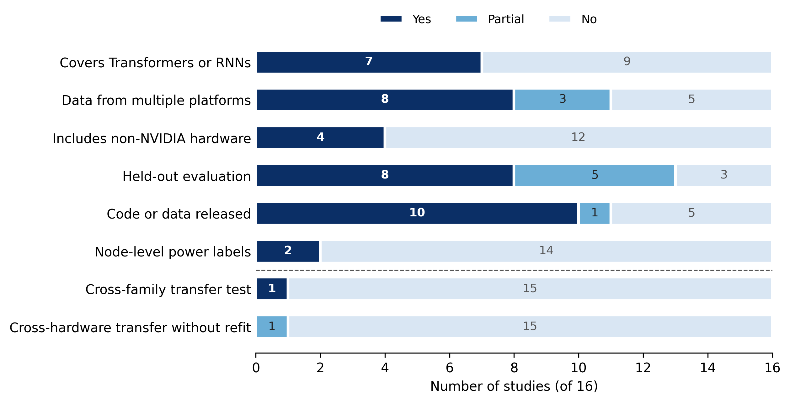
Fig. 7. Number of included studies with each capability that bears on transfer. Partial denotes limited or non-primary evidence; per-study details are given in Table 7.
Table 7. Generalizability matrix. Same setting: evaluated on the hardware and model family used for fitting (in-distribution); recalibrated: refitted with target-platform data; zero-shot: applied to unseen hardware or families without target data.
Study | Families | Hardware (vendor) | Target | Ground truth | Transfer setting
EA-HAS-Bench [27] | CNN | NVIDIA | Energy | pynvml | Same setting (held-out configurations)
EC-NAS [10] | CNN | NVIDIA | Energy | Carbontracker | Same setting (random split)*
CNNGen [31] | CNN | Not reported | Carbon/energy | CodeCarbon | Same setting (random split)
Gratia et al. [17] | CNN | Not reported | Carbon | Not described | Same setting
GREEN [34] | CNN, ViT, Transformer, RNN, recommender | NVIDIA | Energy (normalized) | CodeCarbon | Same setting; unseen datasets
AMPERE [35] | CNN, RNN, Transformer | OPPO and Apple phones, NVIDIA Jetson, server | Energy | Not described | Held-out channel, width and depth variants; recalibrated per device
del Rey et al. [33] | CNN | NVIDIA | Power/energy | nvidia-smi | Same setting (30% held out)
Liao et al. [20] | CNN, Transformer | NVIDIA A800; RTX 2080 Ti | Power-curve components | nvidia-smi | Held-out configurations; ResNet-50 to ViT/BERT without refit; separate RTX 2080 Ti evaluation
TOs model [18] | MLP, CNN | Intel, AMD, NVIDIA | Energy | On-board sensors | Same setting; recalibrated per platform
BUTTER-E [8] | MLP | Intel CPU, NVIDIA | Energy | Node power (iLO) | In-sample fit only
LLMCarbon [28] | Transformer (dense, MoE) | Google TPU, NVIDIA | Carbon | Published values | External models, no refit†
Mayaki and Charpenay [11] | Transformer, LSTM, GRU | NVIDIA (two GPUs) | Energy | CodeCarbon | Recalibrated per GPU
Mayaki [32] | Transformer (BERT) | NVIDIA | Energy | Nsight + CodeCarbon | Same setting (70/30 split)
Newkirk et al. [30] | Transformer, CNN | NVIDIA H100 | Power → energy | Node power | Out-of-sample workloads, same node class‡
Falafels [36] | MLP (federated) | Simulated | Energy | None | Not evaluated
Patel et al. [29] | CNN (federated) | Simulated | Carbon | None | Not evaluated
* EC-NAS also reports measured energy for the subspace of cells with at most four vertices on four NVIDIA GPUs (Titan Xp, RTX 3060, RTX 3090, Quadro RTX 6000); the surrogate is not evaluated across them. † Achieved hardware efficiency and device counts are taken from the same sources used for comparison. ‡ Energy uses the measured run duration.
Architecture coverage extends well beyond CNNs and MLPs, with Transformers or recurrent networks in seven studies [11,20,28,30,32,34,35]. Only Liao et al. [20] fit on one family and test on another. Their symbolic-regression model fitted on ResNet-50 predicts ResNet-50 valley-phase energy with 2.63% mean relative error (MRE), rising to 7.65–7.80% for other ResNets and to 9.88% for ViT and 9.66% for BERT; for peak-phase energy the error rises from 3.76% to 21.95% (ViT) and 20.84% (BERT). The authors attribute the loss to structural dissimilarity. Hardware diversity is narrower. Twelve studies use only NVIDIA GPUs or simulated or unreported hardware, and four include other vendors: Intel and AMD CPUs [18], Intel CPU nodes [8], OPPO and Apple smartphones [35] and Google TPUs [28]. Liao et al. [20] also report a separate evaluation on an RTX 2080 Ti (2.12% MRE for valley-phase energy) without stating whether the model was refitted. No study predicts on unseen hardware without target-device data.
Reported accuracy takes incompatible forms (Fig. 8). R² ranges from 0.787 to 0.98 [11,27,32]. Kendall’s τ is 0.9030 for EC-NAS [10] and 0.77–0.83 for CNNGen [31]. Percentage errors range from 2.59–2.67% for valley-phase energy [20] and 5.4% out-of-sample node energy [30] to approximately 10% mean on-device error [35]. LLMCarbon reports 0.32–8.2% absolute error against five published LLM footprints [28], and BUTTER-E in-sample errors of ±2.74% (GPU) and ±20.2% (CPU) [8]. Further metrics include a held-out RMSE of 30.36 kJ [33], a normalized MAE of 0.010–0.035 [34] and an undefined “precision” of 93.61–99.51% [18]. Because these figures differ in target, metric and evaluation protocol, they describe each study in its own context and do not constitute a ranking.
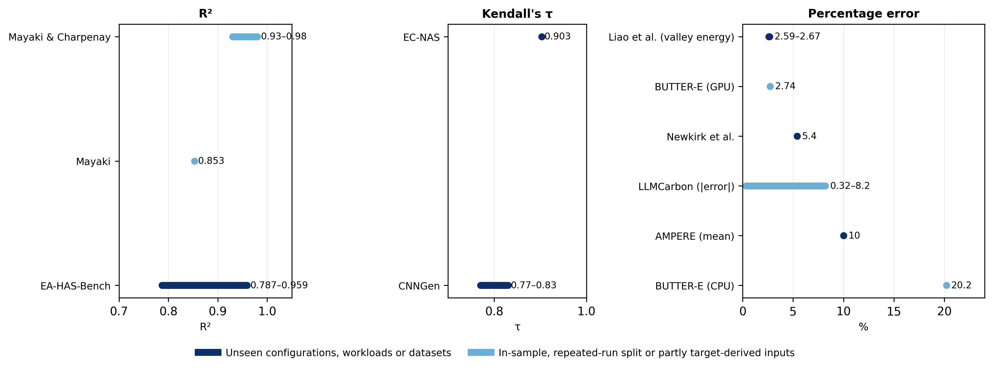
Fig. 8. Reported accuracy of the included predictors, grouped by metric. Dark bars denote evaluation on unseen configurations, workloads or datasets; light bars denote in-sample fit, repeated-run splits or partly target-derived inputs. Values are not comparable across studies.

4. Discussion

4.1 Cross-architecture transfer
A priori predictors are not confined to CNNs and MLPs: within the reviewed corpus, seven studies cover Transformers or recurrent networks, including power-law models for Transformer, LSTM and GRU training [11]. Coverage, however, is not transfer. In every evaluated study except Liao et al., all families used for evaluation were also present in the fitting data, and the single cross-family test shows peak-phase energy error rising from 3.76% to about 21% when a ResNet-50 model is applied to ViT and BERT [20]. This matters for the decision that motivates a priori prediction, namely comparing candidates from different families before training any of them, which a predictor validated within one family cannot yet support. Two features of the corpus compound the problem: the three predictors with family-specific encodings (Section 3.4) cannot be applied to another family without redesign, and predictions are made at different scopes, from a phase of the power curve to a whole run, so results from different families rarely share a scale.

4.2 Cross-hardware transfer
The hardware evidence in Section 3.6 supports a narrower claim than cross-hardware generalization: results exist on several devices, but they are limited in breadth and vendor diversity, rely on per-device refitting, and contain no zero-shot test. Refitting for each device [11,18,35] demonstrates that a method can be re-applied, not that a fitted model transfers, and the multi-GPU measurements in EC-NAS characterize between-device variation without evaluating the surrogate across devices [10]. Three studies indicate why hardware cannot be treated as a constant: energy per FLOP shifts with cache residency [8], node power depends on load per node rather than total FLOPs alone [30], and a small architecture may consume more energy on a large GPU through under-utilization [10]. Predictors whose inputs describe only the network will therefore miss device-dependent effects, which argues for explicit hardware covariates and for evaluation on held-out devices, including non-NVIDIA hardware.

4.3 Measurement fidelity
Reported accuracy is accuracy against the labels a study used, so a low error against biased labels reproduces that bias. Software estimators supply the labels in five studies; they combine hardware-interface readings with modeled components, and their accuracy depends on hardware and workload. Fischer [37] compared estimation approaches, including CodeCarbon, with external measurements and reported errors of up to 40%. That study did not test Carbontracker, so its magnitude cannot be transferred to the EC-NAS labels, but it shows that software-estimated labels require validation of their own, consistent with the differences between on-chip tools and an external meter reported by Rodriguez et al. [14]. Component coverage introduces a second, independent difference: a predictor trained on GPU-only labels estimates a smaller quantity than one trained on node-level labels for the same run, so neither the errors nor the predicted energies are comparable between such studies. No study validated its own instrument, and the two studies with node-level measurement [8,30] come closest to an external ground truth.

4.4 Analytical versus learned models
Because no study compares an analytical and a learned predictor on the same measured runs, the two families cannot be ranked; the patterns below are observed within individual studies. Learned regressors and surrogates often take inputs specific to a search space, are mostly evaluated in the same setting used for fitting, and require many measured runs, for example 4,310 architectures for EC-NAS [10] and 1,300 CNNs for CNNGen [31]; Zhang et al. [35] reduce this cost through active learning but still profile each device. Analytical and semi-empirical models are built from counted operations and a few coefficients, which makes them easier to apply to new configurations, yet they still require per-device calibration [11,18], and the models that add memory traffic [8,32] show that operation counts alone are insufficient. Faiz et al. [28] combine both, pairing an analytical pipeline with a fitted hardware-efficiency term. A head-to-head evaluation on shared measured runs is needed before either family can be recommended.

4.5 Implications for sustainable computing
Current a priori predictors can rank candidates within one search space on one device, but their absolute estimates depend on what the labels measured and remain valid mainly on the hardware and family used for fitting. Where an estimate in CO₂e is required, the conversion from energy through grid intensity and PUE, and any embodied emissions, should be reported separately from the predicted energy. Comparability across studies would improve if future predictor papers reported a common minimum set of items. Table 8 lists these items, each tied to a gap observed in this review.
Table 8. Minimum reporting checklist for a priori training-energy predictor studies.
No. | Item to report | Gap observed in this review
1 | Target quantity and unit (energy, power or carbon; J, kWh, W or CO₂e) | Targets differ across the corpus: 11 energy, 2 power, 3 carbon (Section 3.2)
2 | Prediction scope (whole run, epoch, round or phase) and training budget assumed | Scope ranges from power-curve phases to whole runs, so results rarely share a scale (Section 3.2)
3 | Inputs, and confirmation that none requires running the target job | Six near-eligible studies required part of the target job (Table 4)
4 | Ground-truth instrument, components covered and sampling interval | Five studies do not report how their labels were measured (Section 3.5)
5 | Validation of the instrument against an external meter, at least on a subset of runs | No included study validated its instrument (Section 3.5)
6 | Hardware models and vendors used for labels and evaluation | Two studies do not report hardware; 12 use only NVIDIA, simulated or unreported devices (Section 3.6)
7 | Number of configurations and runs, and how repeated runs are handled | Five studies used weak held-out sets, such as random splits over repeated runs of the same configurations (Section 3.3)
8 | Unit of the train/test split (configuration, workload, dataset, family or device) | Only one study held out an architecture family; none held out a device without refitting (Section 3.6)
9 | Transfer setting: same setting, recalibrated (with amount of target data) or zero-shot | Seven studies were evaluated only in the setting used for fitting (Section 3.6)
10 | Defined error metrics in physical units on held-out data, with relative error | Eight studies report only rank correlation, unitless or undefined metrics, or inconsistent values (Section 3.3)
11 | Carbon conversion factors (grid intensity, PUE) and embodied emissions reported separately from energy | Carbon targets combine predicted energy with assumed conversion factors (Section 2.1)
12 | Code and data availability | Five studies release neither code nor data (Fig. 7)
Combining existing measured datasets is an attractive route to broader coverage, but pooling them directly would be misleading. BUTTER-E (MLPs, node-level power, CPU and V100 nodes) [8] and EC-NAS (CNN cells, Carbontracker, Quadro RTX 6000) [10] differ in architecture family, measurement system, component coverage, hardware and training regime, so a pooled model could learn these differences rather than how architecture determines energy. Fig. 9 outlines a harmonization and calibration study that would precede any joint model: conversion to a common target, unit and component scope; hardware recorded as explicit covariates; domain adaptation between datasets; leave-one-family-out and held-out-hardware evaluation; and watt-meter validation on a subset of runs.
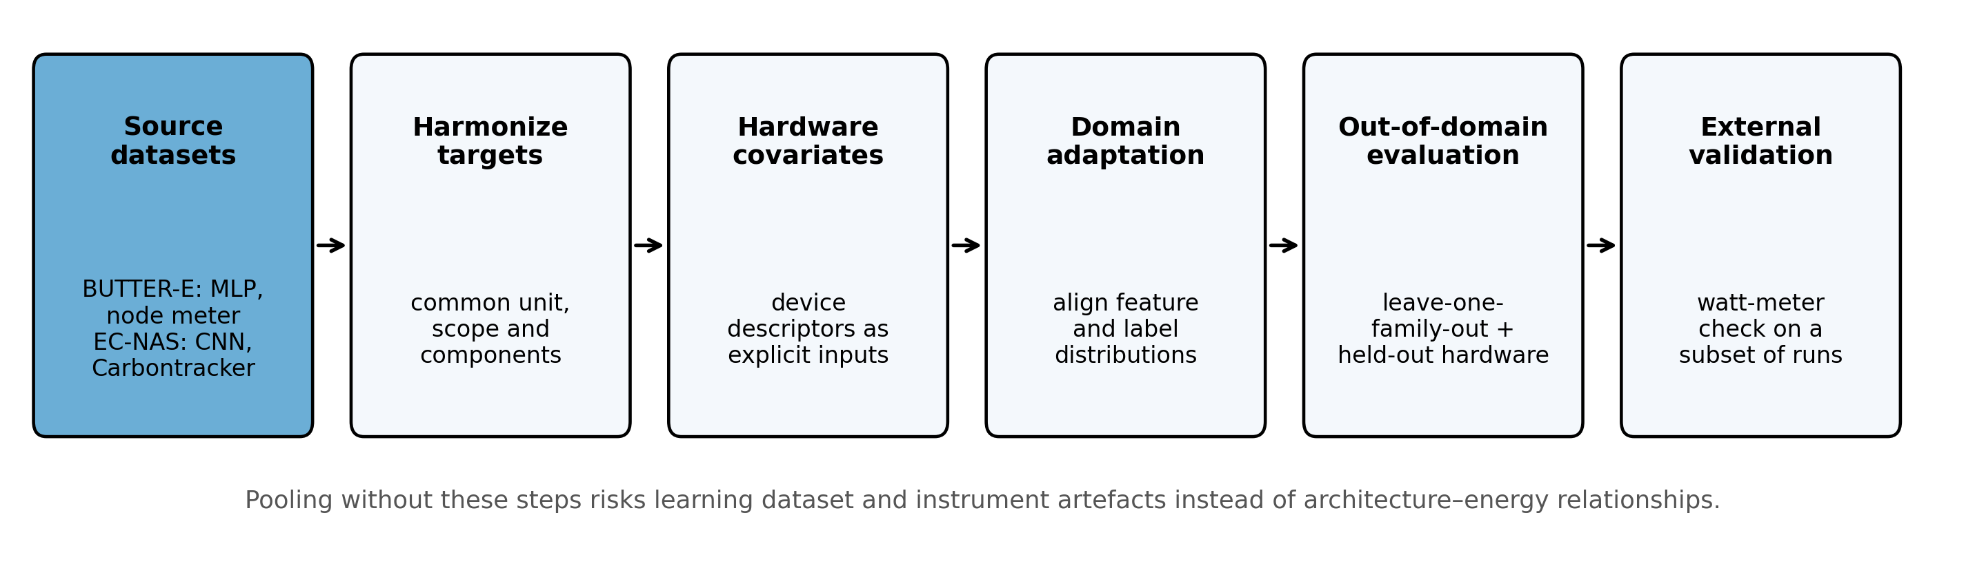
Fig. 9. Proposed harmonization and calibration protocol for combining measured training-energy datasets.

5. Threats to Validity
Search coverage. Six databases were searched, but the fields searched differ by platform (Table 2) and three platforms required adapted queries (Section 2.3), which affects precision and recall differently across sources. No keyword search retrieves every relevant study, because authors describe the same idea in different terms, and subject-area filters can exclude relevant journals; the recall check missed one of four known eligible studies, and another eligible study was identified only through prior knowledge. Citation searching and re-assessment of the pilot search reduce this risk without removing it. Grey literature and proprietary industrial tools are not covered.
Single reviewer. Screening, data extraction and quality appraisal were performed by a single reviewer, which increases the risk of selection and extraction errors. To limit this, the title stage was deliberately inclusive, unclear abstracts were carried forward to full text, every extracted value was checked against the source paper, and quality scores were assigned in two separate passes reconciled against written rules. Inter-rater agreement could not be computed.
Language and access. Only English-language papers were eligible, and one candidate (MC2) was excluded because it is available only in Chinese, so language bias is possible. Three further full texts could not be obtained because of paywalls, and any of these four could have met the inclusion criteria.
Preprints. Preprints were eligible, and four included studies were available only as preprints at the search date; they were appraised with the same instrument and not weighted differently, and their results may change on peer review.
Evolving literature. Most included studies appeared in 2024–2026, and new work continues to appear. Statements that a capability has not been demonstrated refer to the corpus as of the search date.
Heterogeneity and measurement bias. Differences in target quantity, scope, instrument, hardware and evaluation protocol preclude direct comparison of reported accuracies and meta-analysis. Most labels come from software estimators or GPU power interfaces, so reported errors measure agreement with those instruments rather than with wall-plug energy.
Publication bias. Positive results in a single setting dominate the corpus, whereas failures to transfer are rarely published, which may overstate the maturity of the field.

6. Conclusion
This review identified 16 studies, located in searches run between 29 September and 3 October 2026, that predict neural-network training energy, power or carbon before training starts. Within a fixed setting, meaning one search space or model family on hardware the predictor was fitted on, a priori prediction consistently reports low error: learned surrogates and calibrated analytical models achieve low errors against their own labels, and the methods cover CNNs, MLPs, recurrent networks and Transformers, including large language models. Three questions remain open. Transfer across architecture families has been tested once, with errors rising about fourfold for valley-phase energy and almost sixfold for peak-phase energy; transfer across hardware relies on per-device refitting, with no zero-shot evidence and a strong concentration on NVIDIA devices; and the labels themselves, drawn mostly from software estimators or GPU interfaces with differing component coverage and no external validation, make reported accuracies incomparable across studies. The research agenda, in order of priority, is: (1) common reporting of target quantity, unit, scope, component coverage and transfer setting, following the checklist in Table 8; (2) validation of training-energy labels against external watt-meters on at least a subset of runs; (3) leave-one-family-out and held-out-hardware evaluation, including non-NVIDIA devices; (4) harmonization of measured datasets such as BUTTER-E and EC-NAS before joint modeling; and (5) head-to-head evaluation of analytical and learned predictors on the same measured runs.

Data Availability
The search log, screening decisions with reasons, full-text eligibility decisions, extracted data and quality scores are provided as Supplementary Material S1.

CRediT Authorship Contribution Statement
Vanessa Atta-Fynn: Investigation, Data curation, Methodology, Formal analysis, Visualization, Writing – original draft.
Kofi Sarpong Adu-Manu: Conceptualization, Supervision, Methodology, Writing – review & editing.

Declaration of Competing Interest
The authors declare that they have no known competing financial interests or personal relationships that could have appeared to influence the work reported in this paper.

Funding
This research did not receive any specific grant from funding agencies in the public, commercial, or not-for-profit sectors.

Declaration of Generative AI and AI-Assisted Technologies in the Writing Process
During the preparation of this work the authors used Claude (Anthropic) to suggest screening decisions and reasons for records at the title, abstract and full-text stages, to pre-fill data-extraction fields from the full texts, and to assist with drafting and editing the manuscript text, generating figure code and checking reference metadata. All screening and eligibility decisions were made by the authors against the written criteria, and every extracted value was checked against the source paper. After using this tool, the authors reviewed and edited the content as needed and take full responsibility for the content of the publication.

References
[1] E. Strubell, A. Ganesh, A. McCallum, Energy and policy considerations for deep learning in NLP, in: Proc. 57th Annu. Meet. Assoc. Comput. Linguist., 2019, pp. 3645–3650. https://doi.org/10.18653/v1/P19-1355
[2] D. Patterson, J. Gonzalez, Q. Le, C. Liang, L.-M. Munguia, D. Rothchild, D. So, M. Texier, J. Dean, Carbon emissions and large neural network training, arXiv:2104.10350, 2021. https://doi.org/10.48550/arXiv.2104.10350
[3] R. Schwartz, J. Dodge, N.A. Smith, O. Etzioni, Green AI, Commun. ACM 63 (12) (2020) 54–63. https://doi.org/10.1145/3381831
[4] L.F.W. Anthony, B. Kanding, R. Selvan, Carbontracker: Tracking and predicting the carbon footprint of training deep learning models, ICML Workshop on Challenges in Deploying and Monitoring Machine Learning Systems, arXiv:2007.03051, 2020. https://doi.org/10.48550/arXiv.2007.03051
[5] P. Henderson, J. Hu, J. Romoff, E. Brunskill, D. Jurafsky, J. Pineau, Towards the systematic reporting of the energy and carbon footprints of machine learning, J. Mach. Learn. Res. 21 (248) (2020) 1–43.
[6] B. Courty, V. Schmidt, et al., mlco2/codecarbon (v3.2.3) [Software], Zenodo, 2026. https://doi.org/10.5281/zenodo.18731928
[7] E. García-Martín, C.F. Rodrigues, G. Riley, H. Grahn, Estimation of energy consumption in machine learning, J. Parallel Distrib. Comput. 134 (2019) 75–88. https://doi.org/10.1016/j.jpdc.2019.07.007
[8] C.E. Tripp, J. Perr-Sauer, J. Gafur, A. Nag, A. Purkayastha, S. Zisman, E.A. Bensen, Measuring the energy consumption and efficiency of deep neural networks: An empirical analysis and design recommendations, arXiv:2403.08151 [preprint], 2024. https://doi.org/10.48550/arXiv.2403.08151
[9] C. Ying, A. Klein, E. Real, E. Christiansen, K. Murphy, F. Hutter, NAS-Bench-101: Towards reproducible neural architecture search, in: Proc. 36th Int. Conf. Mach. Learn., PMLR 97, 2019, pp. 7105–7114.
[10] P. Bakhtiarifard, C. Igel, R. Selvan, EC-NAS: Energy consumption aware tabular benchmarks for neural architecture search, in: Proc. IEEE Int. Conf. Acoust. Speech Signal Process. (ICASSP), 2024, pp. 5660–5664. https://doi.org/10.1109/ICASSP48485.2024.10448303
[11] M. Zoubeirou a Mayaki, V. Charpenay, Modeling energy consumption in deep learning architectures using power laws, in: ECAI 2025, Front. Artif. Intell. Appl. 413, IOS Press, 2025, pp. 936–943. https://doi.org/10.3233/FAIA250900
[12] L. Bouza, A. Bugeau, L. Lannelongue, How to estimate carbon footprint when training deep learning models? A guide and review, Environ. Res. Commun. 5 (11) (2023) 115014. https://doi.org/10.1088/2515-7620/acf81b
[13] R. Verdecchia, J. Sallou, L. Cruz, A systematic review of Green AI, WIREs Data Min. Knowl. Discov. 13 (4) (2023) e1507. https://doi.org/10.1002/widm.1507
[14] C. Rodriguez, L. Degioanni, L. Kameni, R. Vidal, G. Neglia, Evaluating the energy consumption of machine learning: Systematic literature review and experiments, arXiv:2408.15128, 2024. https://doi.org/10.48550/arXiv.2408.15128
[15] B. Kitchenham, S. Charters, Guidelines for performing systematic literature reviews in software engineering, Technical Report EBSE-2007-01, Keele University and Durham University, 2007.
[16] M.J. Page, J.E. McKenzie, P.M. Bossuyt, I. Boutron, T.C. Hoffmann, C.D. Mulrow, et al., The PRISMA 2020 statement: An updated guideline for reporting systematic reviews, BMJ 372 (2021) n71. https://doi.org/10.1136/bmj.n71
[17] A. Gratia, P. Temple, P.-Y. Schobbens, G. Perrouin, Energy-aware neural architecture search: Leveraging genetic algorithms for balancing performance and consumption, in: Artificial Life and Evolutionary Computation (WIVACE 2024), Commun. Comput. Inf. Sci. 2532, Springer, 2025, pp. 173–185. https://doi.org/10.1007/978-3-031-93631-9_14
[18] C. Li, A. Tsourdos, W. Guo, A transistor operations model for deep learning energy consumption scaling law, IEEE Trans. Artif. Intell. 5 (1) (2024) 192–204, published online 2022. https://doi.org/10.1109/TAI.2022.3229280
[19] C. Wohlin, Guidelines for snowballing in systematic literature studies and a replication in software engineering, in: Proc. 18th Int. Conf. Eval. Assess. Softw. Eng. (EASE), 2014, pp. 1–10. https://doi.org/10.1145/2601248.2601268
[20] X. Liao, Y. Li, S. Zhang, X. Wei, J. Hu, Predicting GPU training energy consumption in data centers using task metadata via symbolic regression, Energies 19 (2) (2026) 448. https://doi.org/10.3390/en19020448
[21] J. Han, Y. Chen, Offline performance and energy consumption prediction model of deep learning training tasks, in: Proc. SPIE 12609, 2023, 1260915. https://doi.org/10.1117/12.2671695
[22] L. He, D. Li, C. Jiang, J. Liu, C. Xu, L. Zhang, A predictive offline–online hybrid approach to DNN training energy optimization, Sustain. Comput. Inform. Syst. 51 (2026) 101415. https://doi.org/10.1016/j.suscom.2026.101415
[23] P. Rościszewski, Modeling and simulation for exploring power/time trade-off of parallel deep neural network training, Procedia Comput. Sci. 108 (2017) 2463–2467. https://doi.org/10.1016/j.procs.2017.05.214
[24] S.K. Prashanthi, S.A. Kesanapalli, Y. Simmhan, Characterizing the performance of accelerated Jetson edge devices for training deep learning models, Proc. ACM Meas. Anal. Comput. Syst. 6 (3) (2022) 1–26. https://doi.org/10.1145/3570604
[25] M. Symeonides, D. Trihinas, AtlasFL: A federated learning workload generator with energy and carbon emission support, in: Proc. 3rd Int. Workshop on Testing Distributed Internet of Things Systems, 2025, pp. 13–18. https://doi.org/10.1145/3719159.3721224
[26] V. Sangarya, R. Bradford, J.-E. Kim, Estimating environmental cost throughout model’s adaptive life cycle, in: Proc. AAAI/ACM Conf. AI, Ethics, and Society 7 (2024) 1281–1291. https://doi.org/10.1609/aies.v7i1.31723
[27] S. Dou, X. Jiang, C. Zhao, D. Li, EA-HAS-Bench: Energy-aware hyperparameter and architecture search benchmark, in: Int. Conf. Learn. Represent. (ICLR), 2023.
[28] A. Faiz, S. Kaneda, R. Wang, R. Osi, P. Sharma, F. Chen, L. Jiang, LLMCarbon: Modeling the end-to-end carbon footprint of large language models, in: Int. Conf. Learn. Represent. (ICLR), 2024. arXiv:2309.14393.
[29] K. Patel, S. Mistry, S. Fattah, D. Kanneganti, A. Krishna, M. Mahmud, M. Bhuyan, Designing sustainable federated learning as a service using neural architecture search, arXiv:2608.14359 [preprint], 2026. https://doi.org/10.48550/arXiv.2608.14359
[30] A.C. Newkirk, J. Fernandez, J. Koomey, I. Latif, E. Strubell, A. Shehabi, C. Samaras, Empirically-calibrated H100 node power models for accurate AI training energy estimation, Environ. Res.: Energy 2 (4) (2025) 045016. https://doi.org/10.1088/2753-3751/ae2486
[31] A. Gratia, H. Liu, S. Satoh, P. Temple, P.-Y. Schobbens, G. Perrouin, CNNGen: A generator and a dataset for energy-aware neural architecture search, in: Proc. ESANN, 2024, pp. 173–178. https://doi.org/10.14428/esann/2024.ES2024-77
[32] M. Zoubeirou a Mayaki, The energy consumption of Transformer fine-tuning: A roofline-inspired scaling model, arXiv:2606.23546 [preprint], 2026. https://doi.org/10.48550/arXiv.2606.23546
[33] S. del Rey, L. Cruz, X. Franch, S. Martínez-Fernández, Estimating deep learning energy consumption based on model architecture and training environment, Comput. Stand. Interfaces 99 (2027) 104170, published online 2026. https://doi.org/10.1016/j.csi.2026.104170
[34] F. Betello, A. Purificato, V. Vineis, G. Tolomei, F. Silvestri, One search fits all: Pareto-optimal eco-friendly model selection, arXiv:2505.01468 [preprint], 2025. https://doi.org/10.48550/arXiv.2505.01468
[35] J. Zhang, Z. Wang, H. Wang, T. Song, H. Su, R. Chen, Y. Hua, X. Zhou, R. Ma, M. Pan, H. Guan, AMPERE: A generic energy estimation approach for on-device training, ACM SIGMETRICS Perform. Eval. Rev. 53 (2) (2025) 27–32. https://doi.org/10.1145/3764944.3764951
[36] A.M. Huet de Barochez, S. Plassart, S. Monnet, Falafels: A tool for estimating federated learning energy consumption via discrete simulation, in: Advanced Information Networking and Applications (AINA 2025), Lect. Notes Data Eng. Commun. Technol., Springer, 2025, pp. 141–152. https://doi.org/10.1007/978-3-031-87769-8_13
[37] R. Fischer, Ground-truthing AI energy consumption: Validating CodeCarbon against external measurements, it – Inf. Technol. 67 (4–6) (2026) 155–163. https://doi.org/10.1515/itit-2025-0031

Appendix A. Full search strings
Scopus (TITLE-ABS-KEY; 29 September 2026; 628 records)
TITLE-ABS-KEY((("energy consumption" OR "power consumption" OR "energy cost" OR "energy usage") W/4 (training OR "neural network*" OR "deep learning" OR DNN* OR CNN* OR GPU*)) AND (predict* OR estimat* OR forecast*)) AND NOT TITLE-ABS-KEY(building* OR household* OR "smart grid" OR "power grid" OR "load forecasting" OR "electric vehicle*" OR photovoltaic OR solar OR "wind power") AND PUBYEAR > 2015 AND PUBYEAR < 2027 AND SUBJAREA(COMP)
Web of Science Core Collection (Topic; 29 September 2026; 128 records)
TS=((("energy consumption" OR "power consumption" OR "energy cost" OR "energy usage") NEAR/4 (training OR "neural network*" OR "deep learning" OR DNN* OR CNN* OR GPU*)) AND (predict* OR estimat* OR forecast*)) NOT TS=(building* OR household* OR "smart grid" OR "power grid" OR "load forecasting" OR "electric vehicle*" OR photovoltaic OR solar OR "wind power") AND PY=(2016-2026)
IEEE Xplore (Command Search, Abstract field; 29 September 2026; 282 records; 2016–2026)
(((("Abstract":"energy consumption" OR "Abstract":"power consumption" OR "Abstract":"energy cost" OR "Abstract":"energy usage") NEAR/4 ("Abstract":training OR "Abstract":"neural network*" OR "Abstract":"deep learning" OR "Abstract":DNN* OR "Abstract":CNN* OR "Abstract":GPU*)) AND ("Abstract":predict* OR "Abstract":estimat* OR "Abstract":forecast*)) NOT ("Abstract":building* OR "Abstract":household* OR "Abstract":"smart grid" OR "Abstract":"power grid" OR "Abstract":"load forecasting" OR "Abstract":"electric vehicle*" OR "Abstract":photovoltaic OR "Abstract":solar OR "Abstract":"wind power"))
The All Metadata field returned 3,123 records because of broad IEEE index terms, so the Abstract field was used.
ACM Digital Library (Abstract field; 29 September 2026; 349 records)
[[Abstract: "energy consumption"] OR [Abstract: "power consumption"] OR [Abstract: "energy cost"] OR [Abstract: "energy usage"]] AND [[Abstract: training] OR [Abstract: "neural network"] OR [Abstract: "neural networks"] OR [Abstract: "deep learning"] OR [Abstract: dnn*] OR [Abstract: cnn*] OR [Abstract: gpu*]] AND [[Abstract: predict*] OR [Abstract: estimat*] OR [Abstract: forecast*]] AND NOT [[Abstract: building*] OR [Abstract: household*] OR [Abstract: "smart grid"] OR [Abstract: "power grid"] OR [Abstract: "load forecasting"] OR [Abstract: "electric vehicle"] OR [Abstract: "electric vehicles"] OR [Abstract: photovoltaic] OR [Abstract: solar] OR [Abstract: "wind power"]] AND [E-Publication Date: (01/01/2016 TO 12/31/2026)]
ScienceDirect (title, abstract, keywords; Computer Science; 2016–2026; 29 September 2026; 440 records)
("energy consumption" OR "power consumption" OR "energy usage") AND ("neural network" OR "deep learning" OR DNN) AND (prediction OR estimation OR predicting)
SpringerLink (Computer Science; articles and conference papers; 2016–2026; no language filter; 3 October 2026; 628 records)
Title: ("energy consumption" OR "power consumption" OR energy OR power) AND (predict OR prediction OR predicting OR estimate OR estimation OR estimating OR model OR modeling OR modelling)
Keywords: ("neural network" OR "neural networks" OR "deep learning" OR DNN OR CNN)

The published caption describes a Kendall-Tau correlation coefficient, whereas the plot label reads “Kendall-Tau R²”.
Newkirk et al. predict node power a priori but convert it to energy using the measured duration of each run, so this energy error depends partly on information available only after the run.

